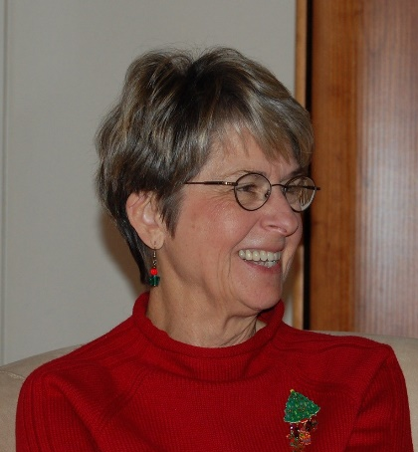
Joan C Shrader
2/14/1939 – 6/2/2018

Joan Carol (McNeil) Shrader, devoted wife and beloved mother and grandmother, passed away peacefully, with her husband of 56 years and daughter at her bedside on June 2, 2018. She had turned 79 in February and suffered from Alzheimer’s.
Joan was born on February 14, 1939 to Marie and Emery McNeil in Sterling, Illinois. In 1961, she met John Shrader, the love of her life and began a relationship that to this day, remains eternal. John and Joan were married on September 8th, 1962 in Sterling, Illinois. Joan and John moved to Seattle area in 1966 and to Mercer Island in 1967. Joan remained on Mercer Island for 37 years, raising her family and making many lifelong friends. She was the backbone of the family, maintaining the household and raising two daughters. Family was everything to Joan, and Joan was deeply loved by her family. She always had a special way of making newcomers feel welcome and a kind word for everyone. Joan’s sweet and gentle spirit will be greatly missed by those whose lives she touched. Over the years, Joan and John helped young adults by providing living space in their basement and meals to assist with their transitions. The lives of nine young adults were forever changed because of her open heart and home. Joan was dedicated to her church, Congregational Church of Mercer Island, with tireless volunteer duties and work as a church secretary, as well as singing in the choir for nearly 30 years.
Joan is survived by her loving husband (John) and two daughters: Kimberly Shrader (Mark Schwartz) and Karen (John) DaSilva; four grandchildren: Johnathan Schwartz, Elizabeth Schwartz, Joseph DaSilva, and James DaSilva. The Shrader Family would like to thank Joan’s caregivers at Aegis on Madison for their loving care of Joan over the past two years.
A service memorializing Joan’s life is planned for Friday, June 29th, 2:00 – 3:00 pm with a reception immediately following at the Congregational Church of Mercer Island. In lieu of flowers, please consider a donation to a charity of your choice. Joan was a passionate protector of the environment and animals.

