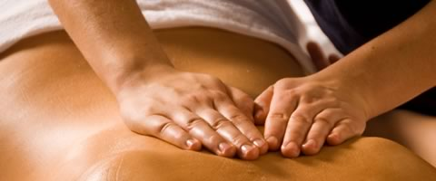

Please call 425-391-6794 or ask at our front desk

to schedule your appointment.

**\* Cash prices - Balance PT is not able to bill insurance at this time for massage.**

730 NW Gilman Blvd C108

Issaquah, WA 98027

(425)-391-6794 phone

www.BalancePT.org

**Balance PT & Wellness**



*Through massage, patterns of holding and guarding can be softened and changed. Myofascial release is a gradual process that honors the body to release when it is ready and safe.***”**

**“**

• Myofascial Release

• Deep Tissue Work

• Relaxation Techniques

• Pain Relief

• Trauma Recovery

• Therapeutic Movement

• Breath Work

**Introductory Pricing\***

$80 for one-hour

$110 for one & half-hours

$150 for two-hours

Sheri’s goal as a practitioner is to help clients integrate body, mind, and heart. She works with anyone seeking relaxation, pain relief, connection to the body, or connection to their trauma stories.

Sheri has been a licensed

massage therapist since 2000.

She specializes in myofascial

release, deep tissue, and

relaxation techniques. Her

emphasis in continuing

education is under the teachings of John Barnes. She has been a dancer and dance-instructor for over 30 years. In addition to being a LMT & dance-instructor, Sheri teaches Kinesiology, Stretch and Strength, and Foam Roller classes. In 2013, she received her Certificate from The Allender Center in Seattle, with a focus on Abuse and Trauma.

Your Partner for Wellness

Balance PT & Wellness is pleased to offer massage therapy by

**sheri lewis, lmT**