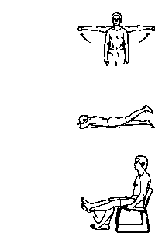
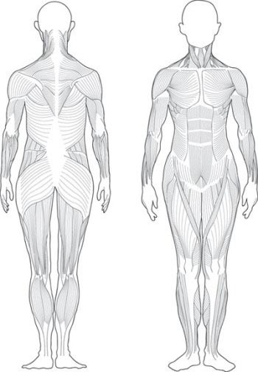
Instructions:
Color the muscle and match it to the exercise.
1

2

3

730 NW Gilman Blvd Suite C-108, Issaquah, WA 98027 Ph: 425-391-6794 Fx: 425-391-1525 www.balancept.org

